**TO SUPPLY LEFTOVER FOOD TO POOR**

**College Name: Shri Nehru Maha Vidhyalaya College of Arts**

**and Science**

**College Code: bru26**

**TEAM ID:** NM2025TMID20787

**TEAM MEMBERS:**

**Team LeaderName:** Priyadharsini S

**Email:** 23snmvbcapriyadharshinis@gmail.com

**Team Member1:** Prema P

**Email:** 23snmvbcaprema@gmail.com

**Team Member:** Nishanthini R

**Email:** nisha975150@gmail.com

**Team Member:** Sanmathi M

**Email:** 23snmvbcasanmathi@gmail.com

**1.INTRODUCTION**

**1.1 Project Overview**

A project to supply food to the poor aims to provide essential nutrition to underprivileged individuals and families, often by collecting surplus food from sources like restaurants and events and distributing it to needy communities. Key components include partnering with donors and volunteers, creating logistics and tracking systems, managing food collection and distribution centers, and ensuring the food's quality and hygiene standards are met.

**1.2 Purpose**

The primary objective of supplying food to the poor is to alleviate hunger and food insecurity, ensuring immediate access to essential nutrition for survival and well-being.

**DEVELOPMENT PHASE**

**Creating Developer Account:**

By using this URL **-** [**https://www.salesforce.com/form/developer-signup/?d=pb**](https://www.salesforce.com/form/developer-signup/?d=pb)

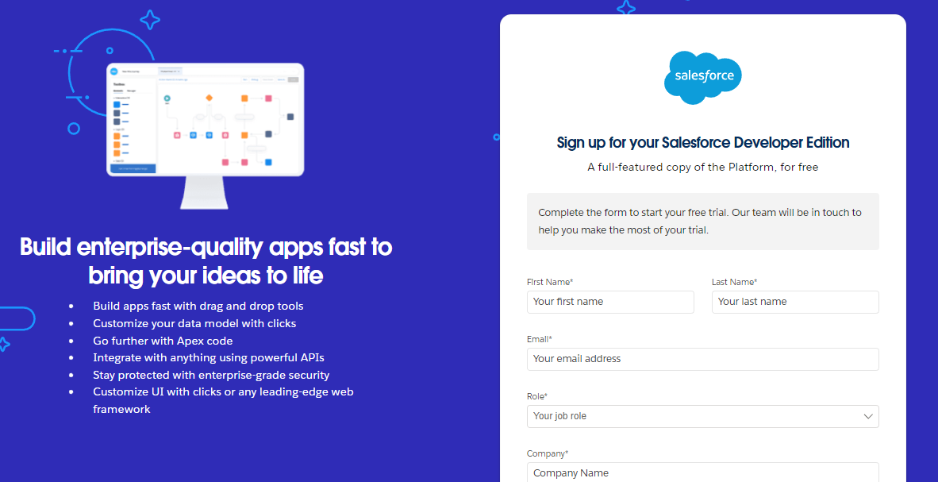

● Created objects:create venue object,create drop off object,create task object,create executiondetail

Creatting a venue object:

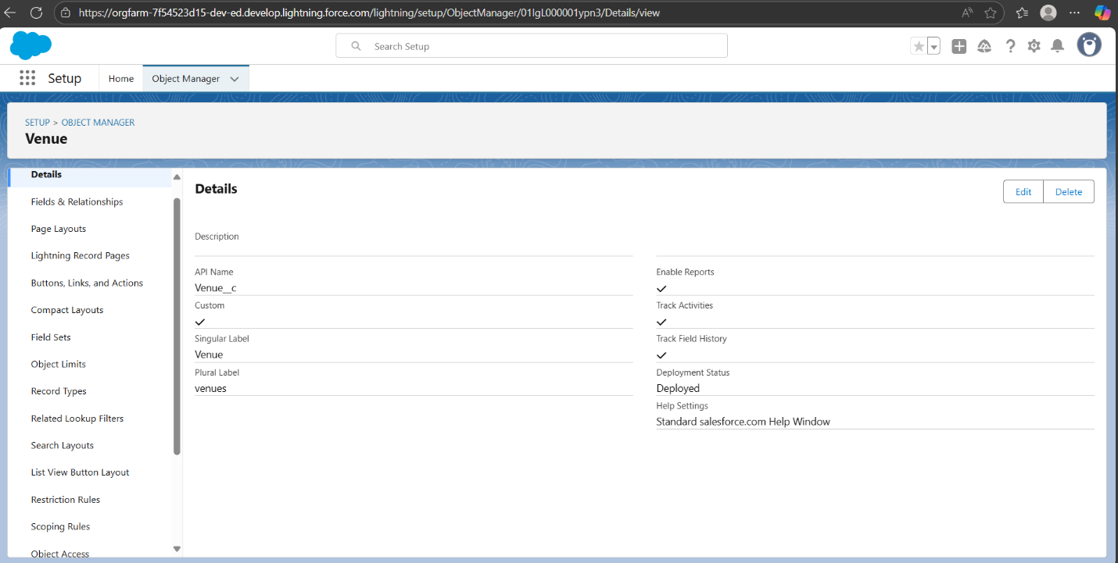

Create drop off-object :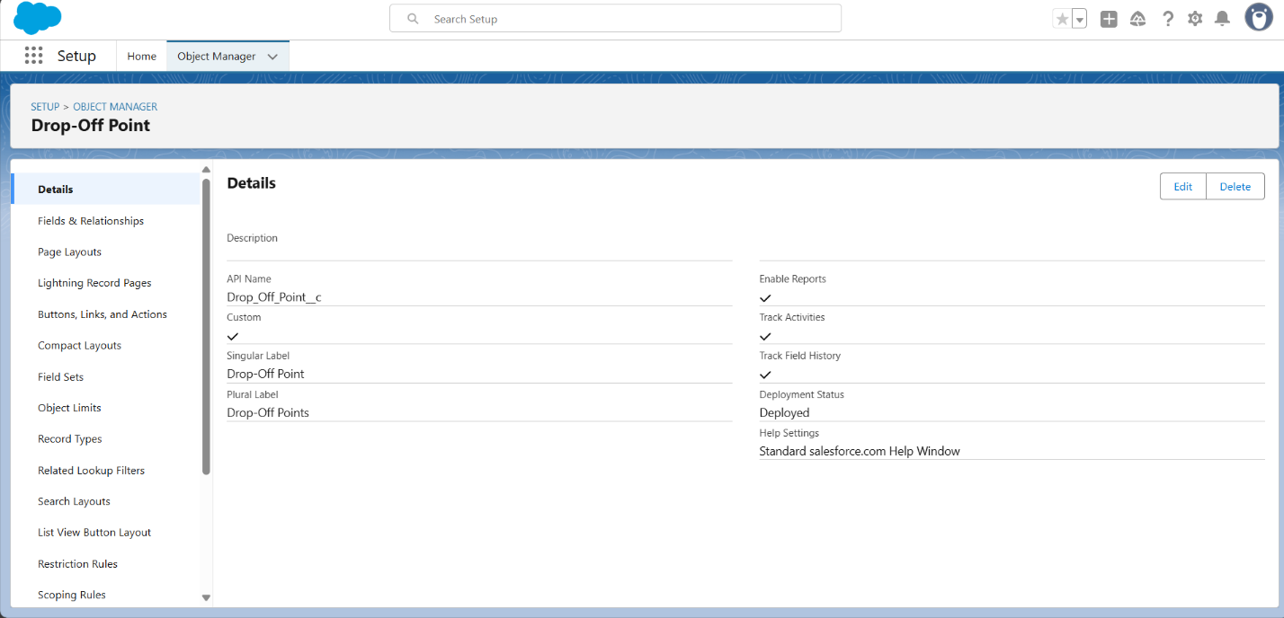

Creating task object

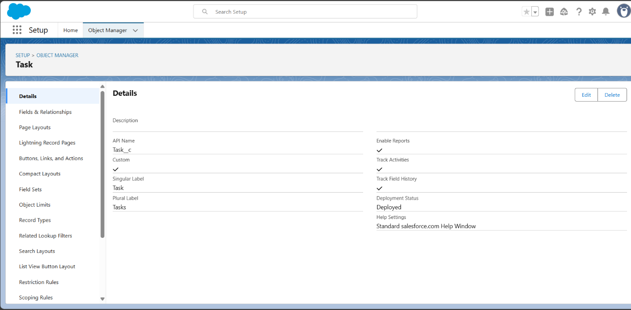

Create volunteer object

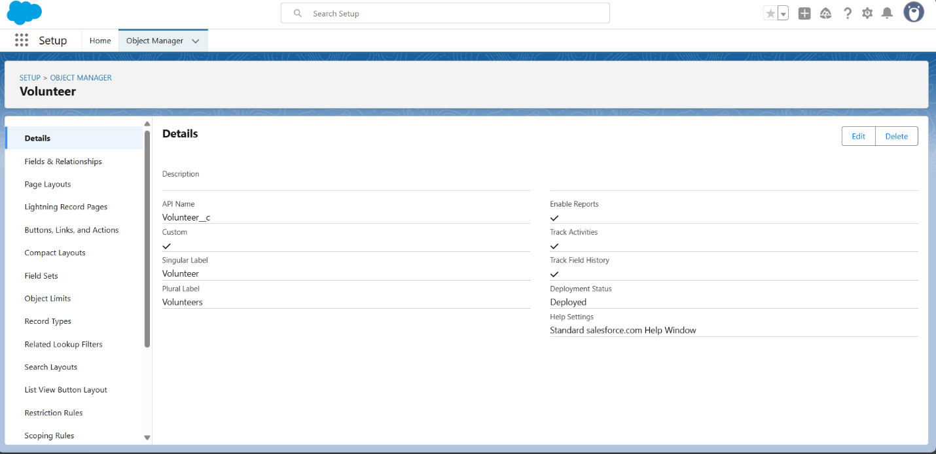

Create Execution Details Object:

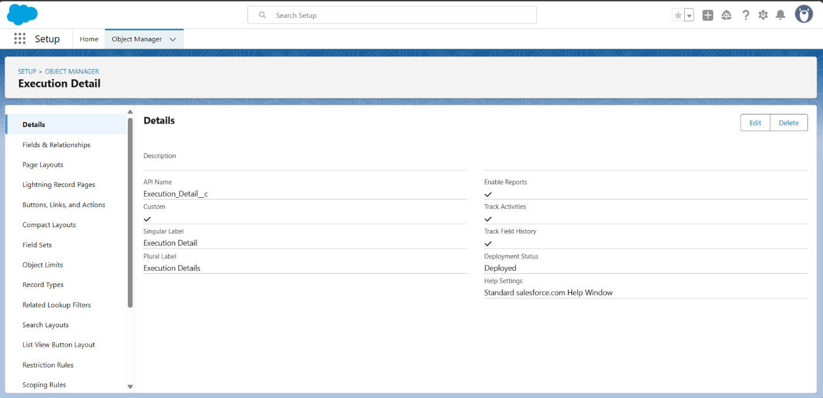

Creating a Custom Tab:

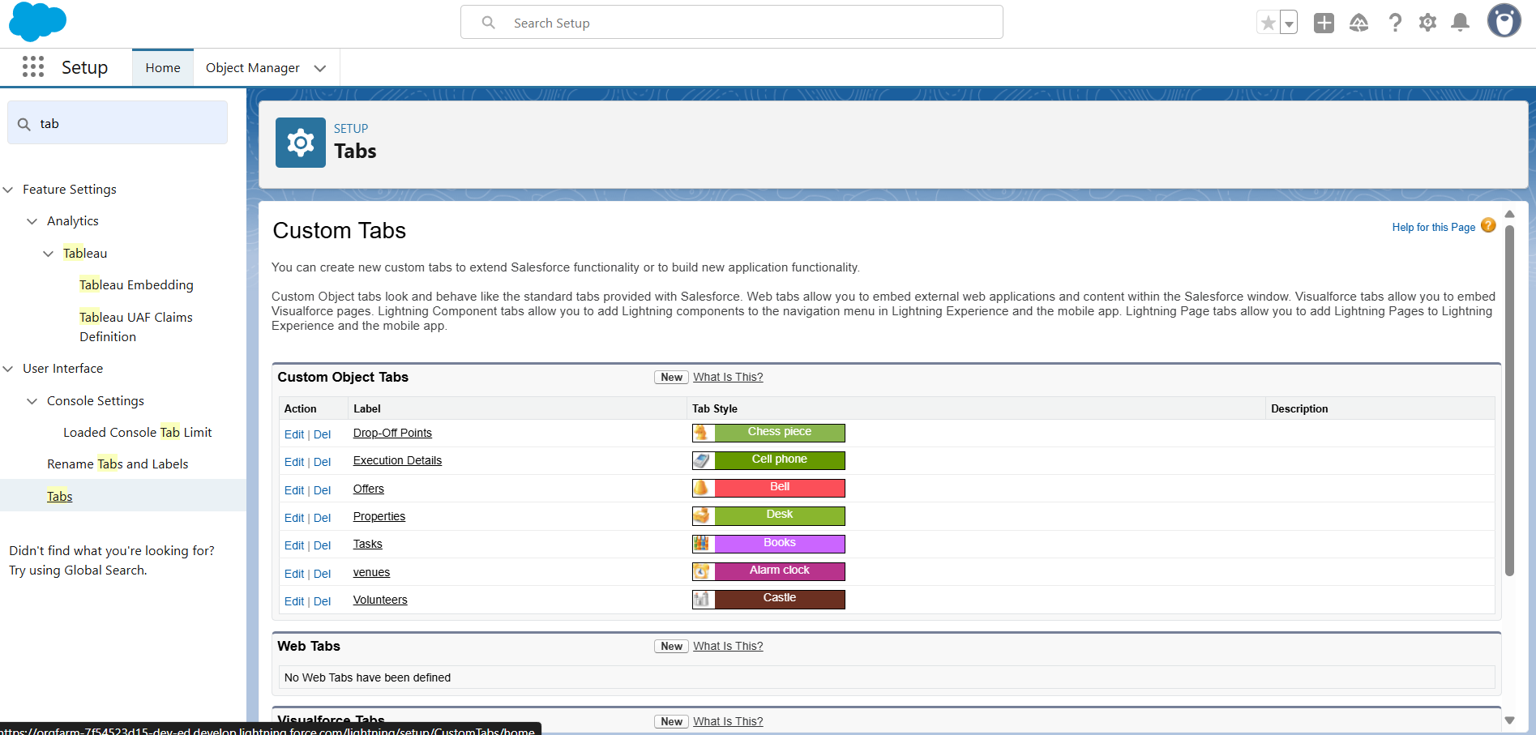

Create a Lightning App:

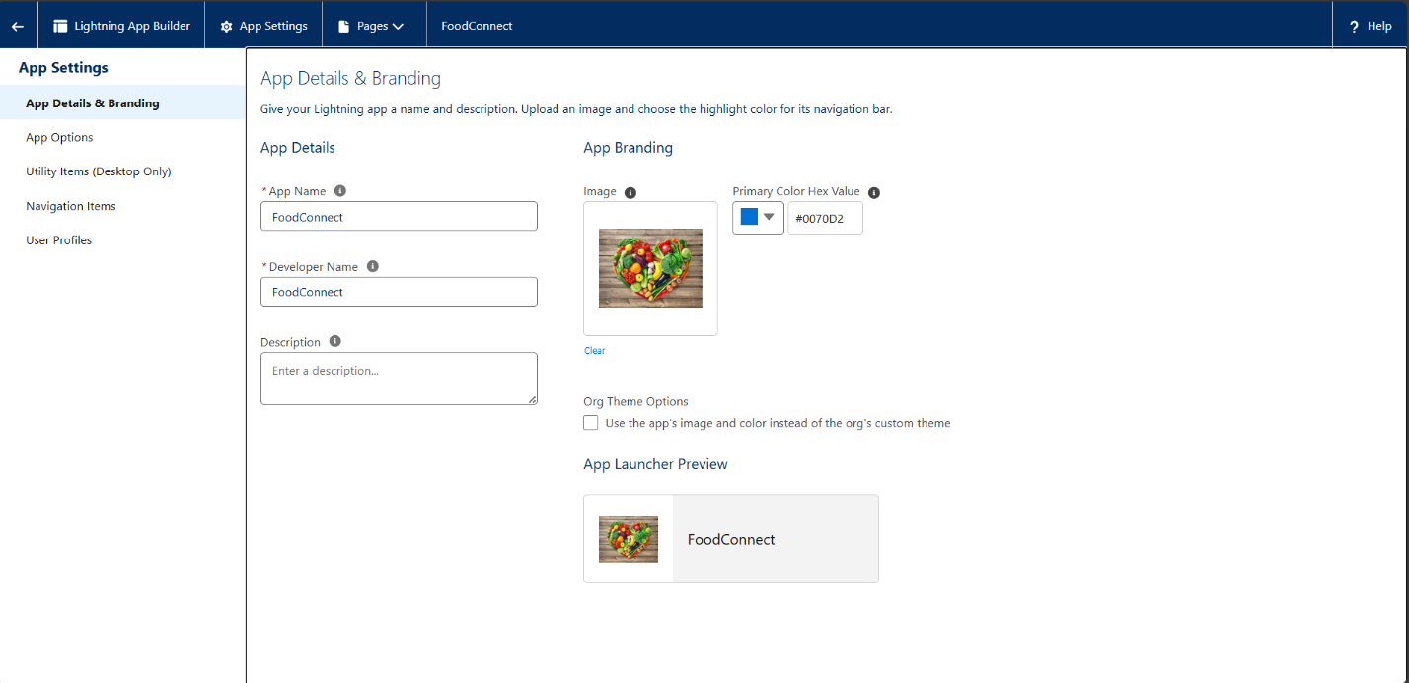

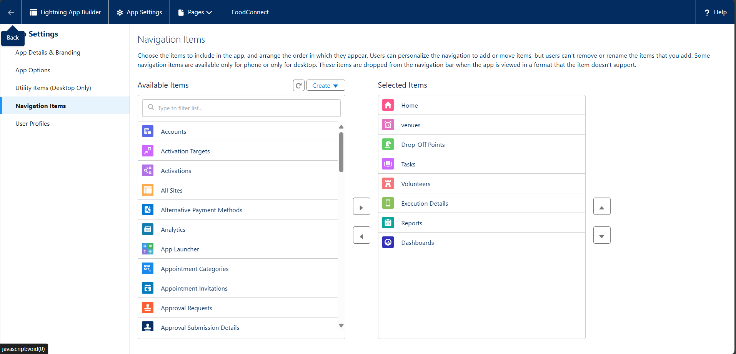

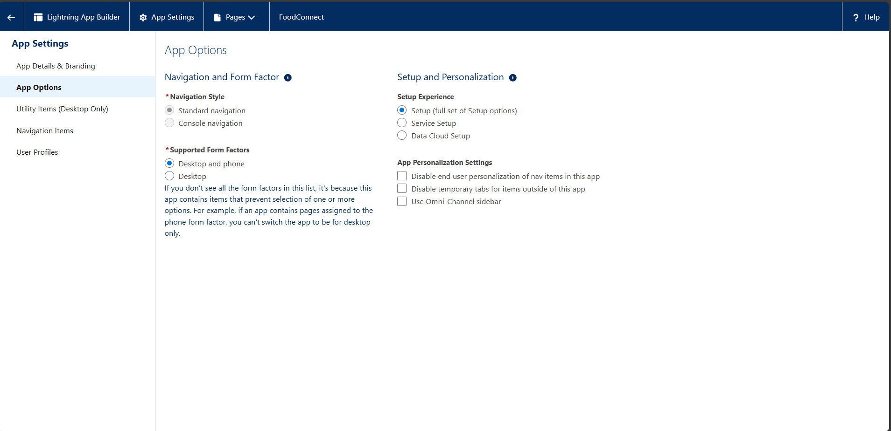

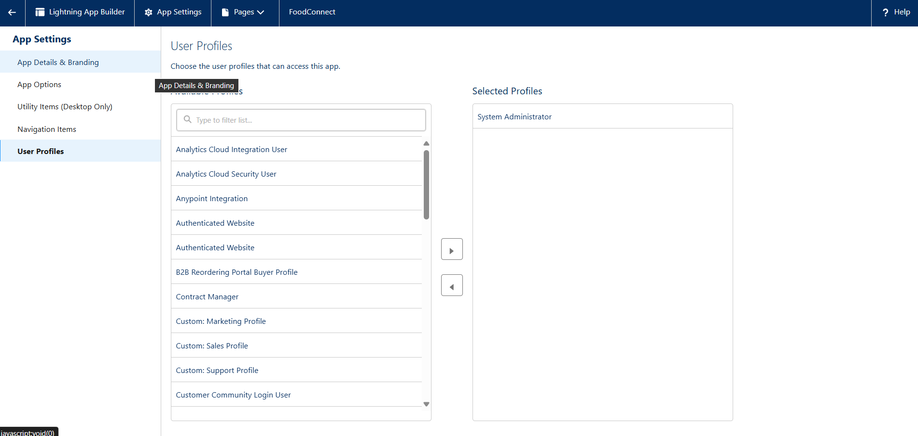

Creating Fields on Venue Object:

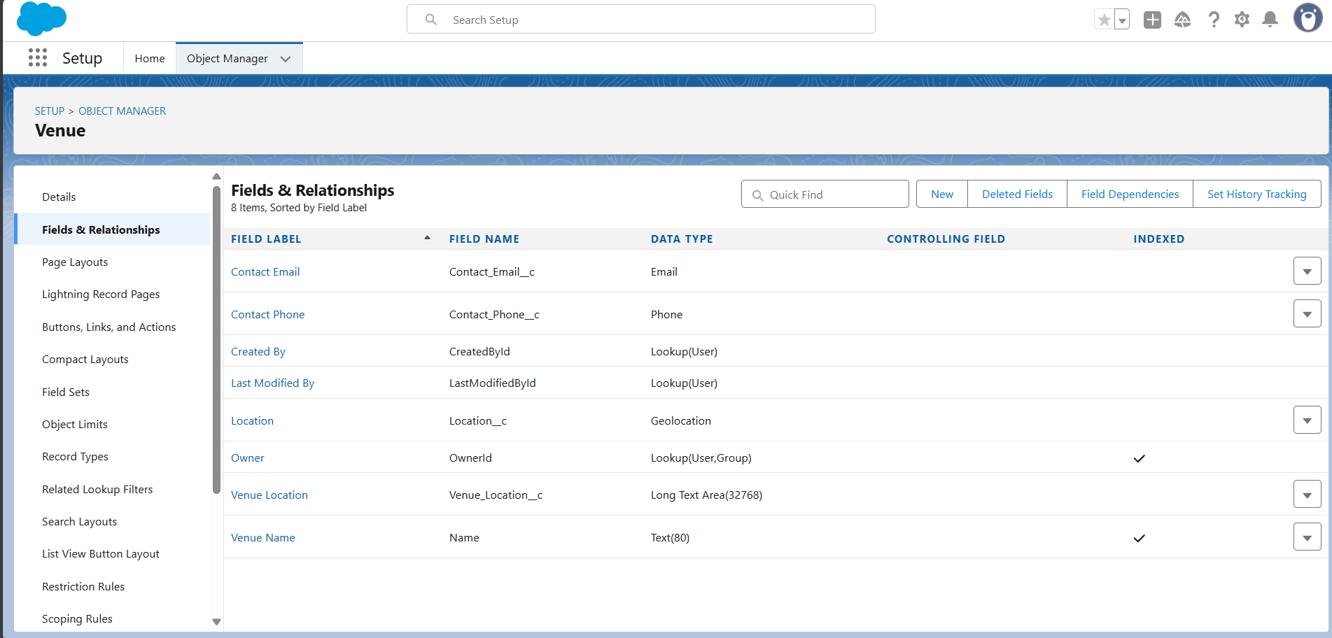

Creating Fields for Drop-off Point Object:

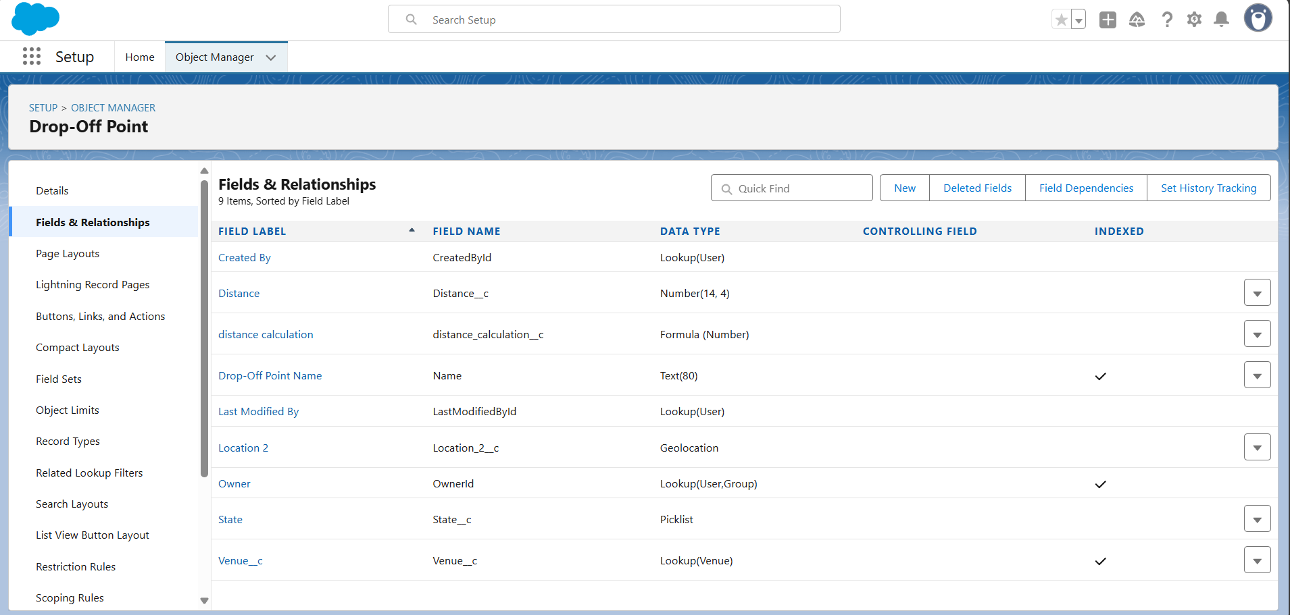

Creating Fields on Task Object:

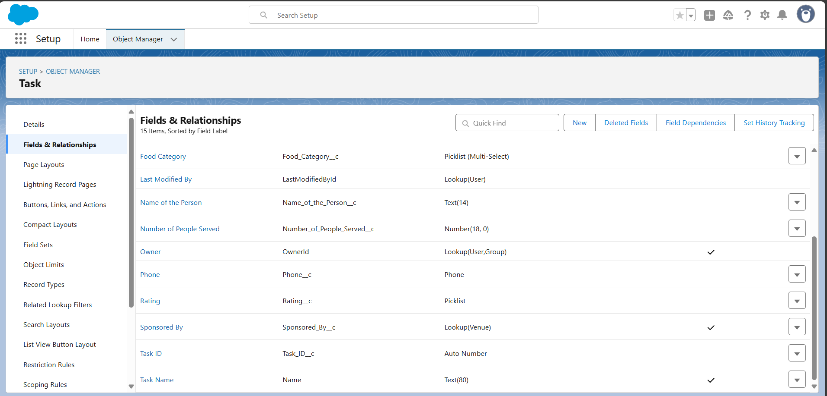

Creating Fields on Volunteer Object:

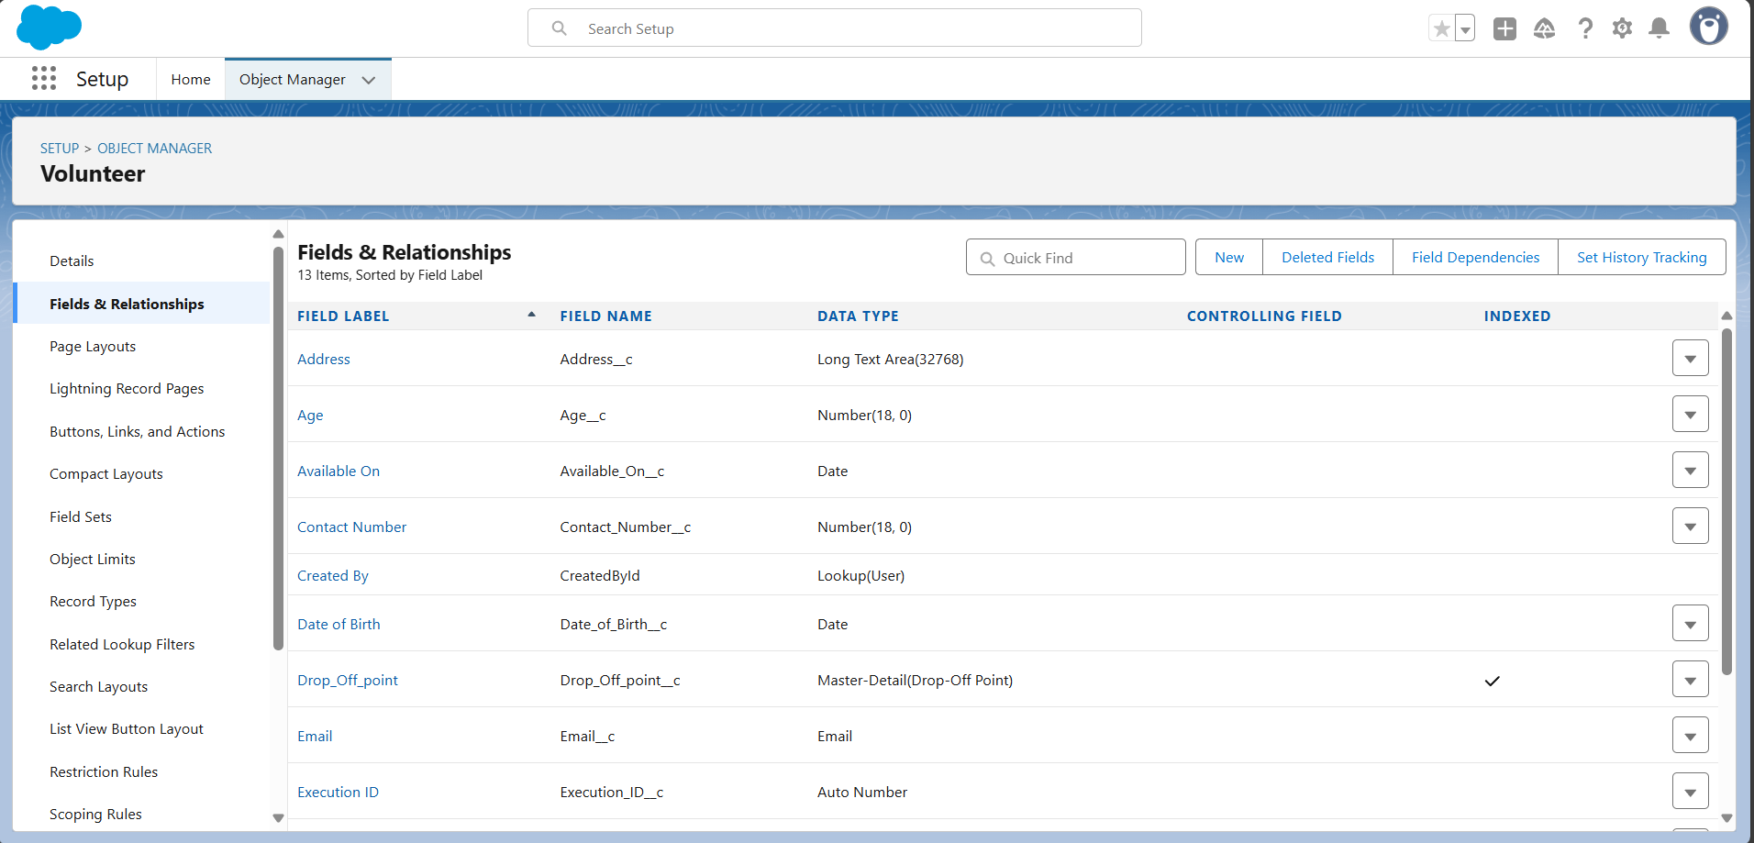

Creating Flow for Venue Object:

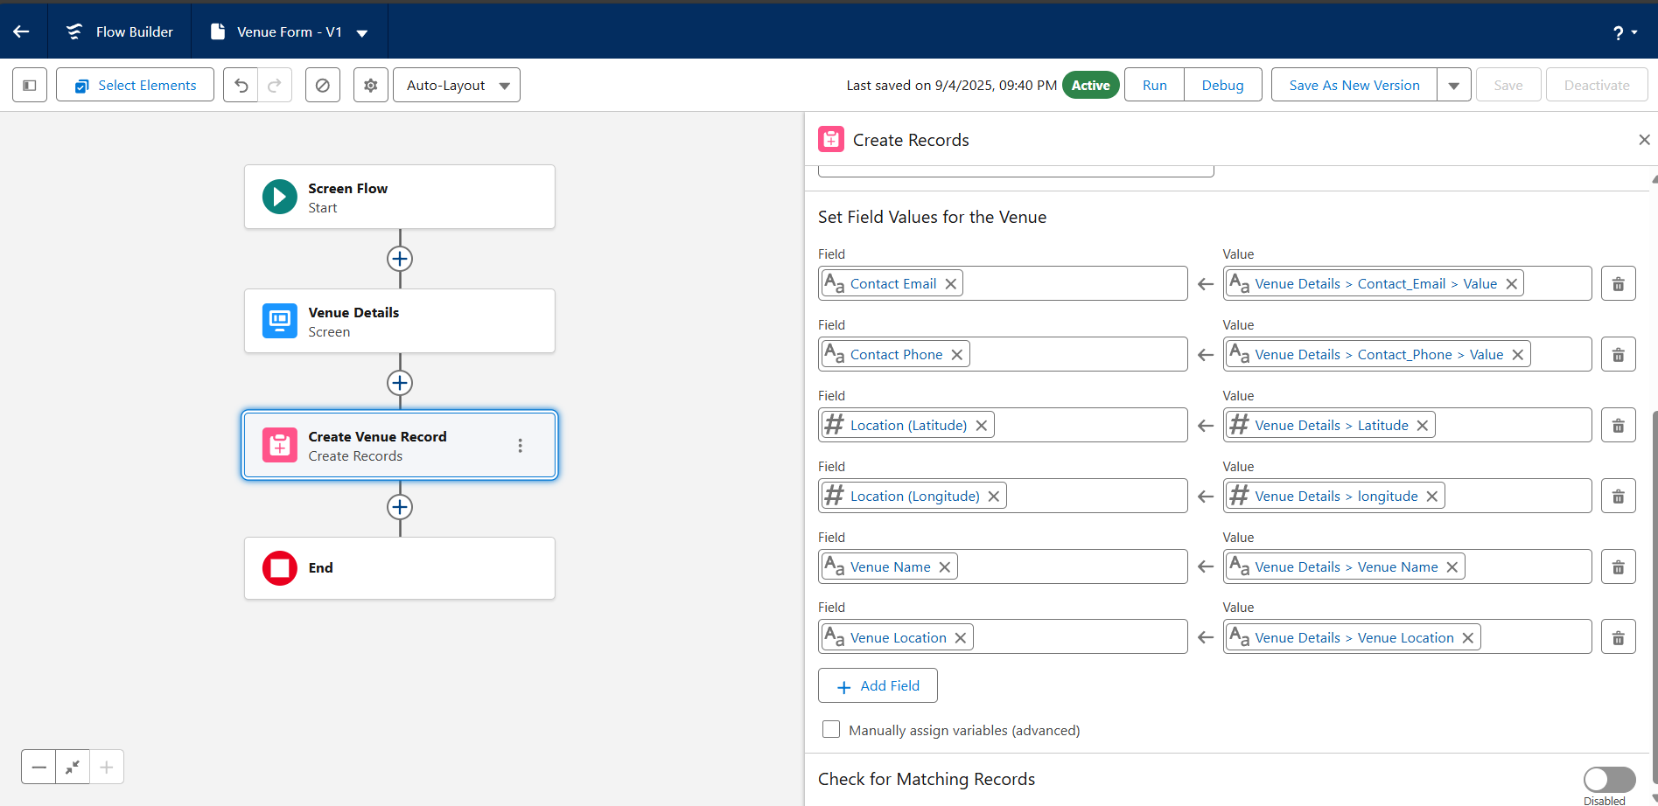

Creating a triger:

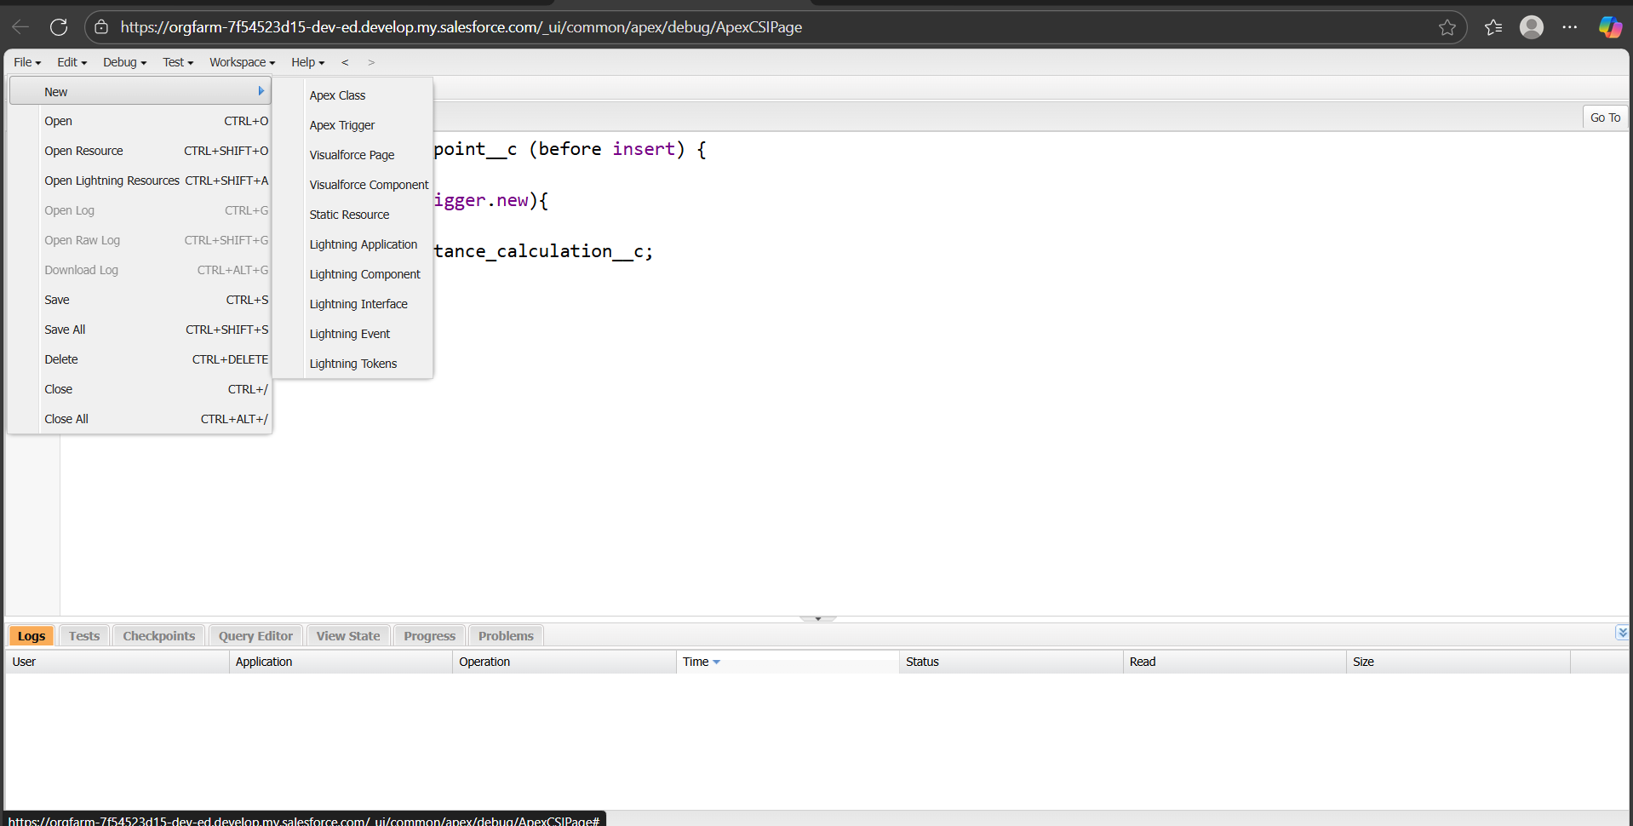

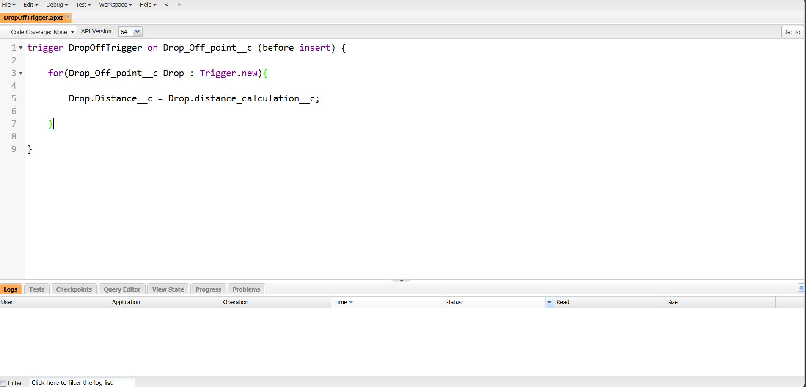

Profiles:

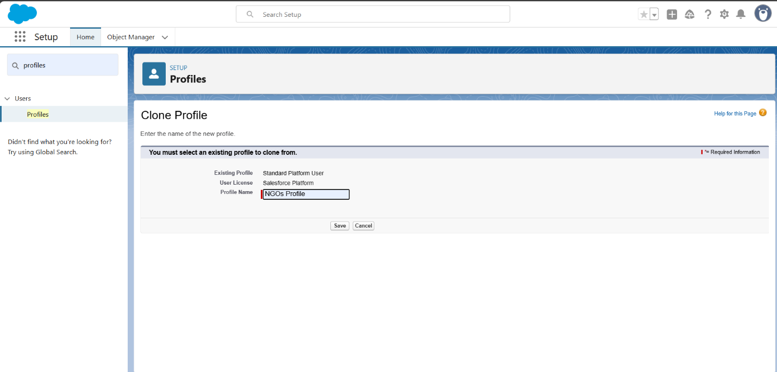

Creation of user:

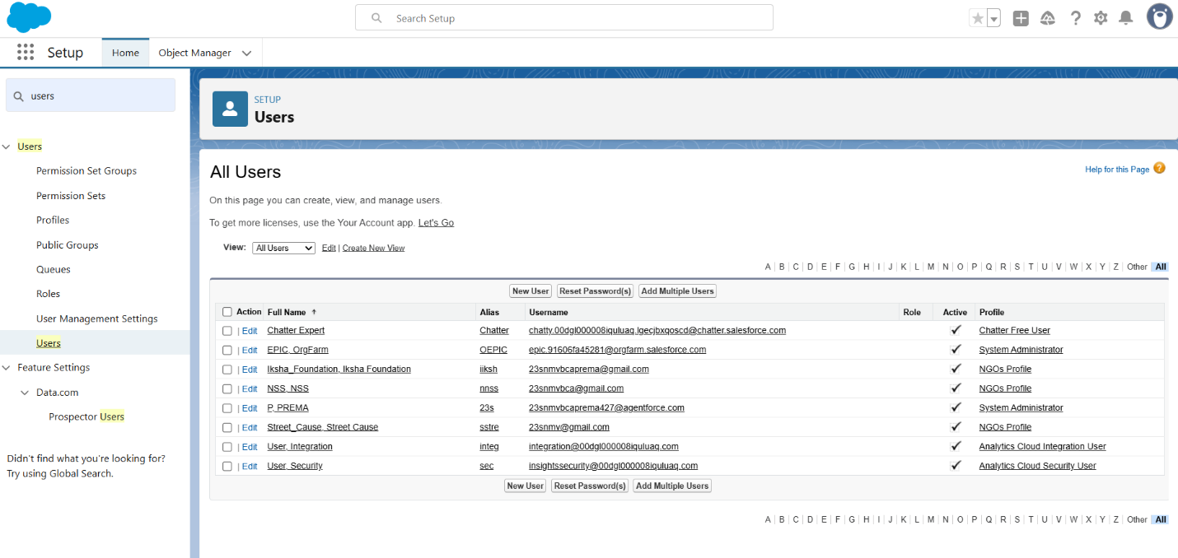

Public groups:

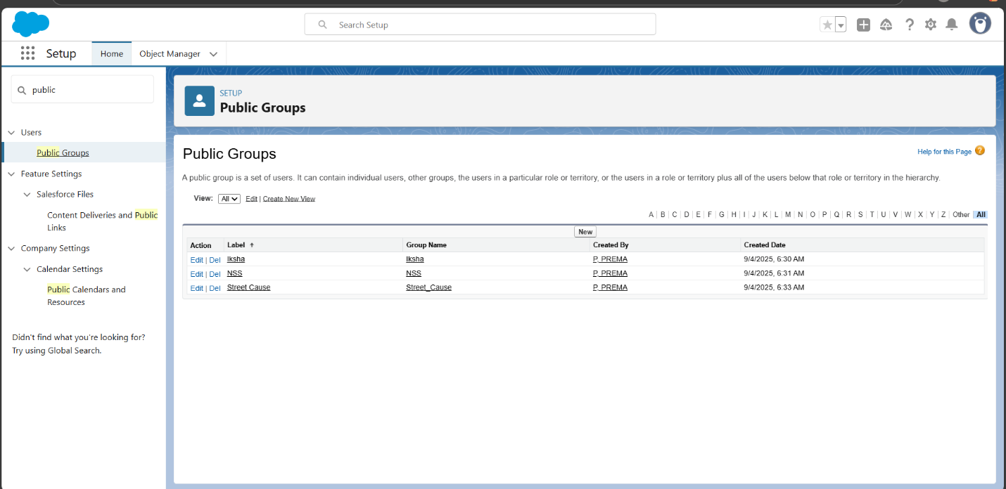

Report types:

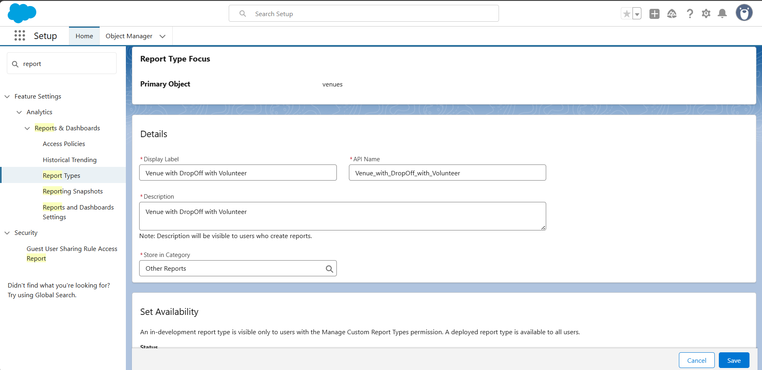

Creation of Report on Venue with DropOff with Volunteer:

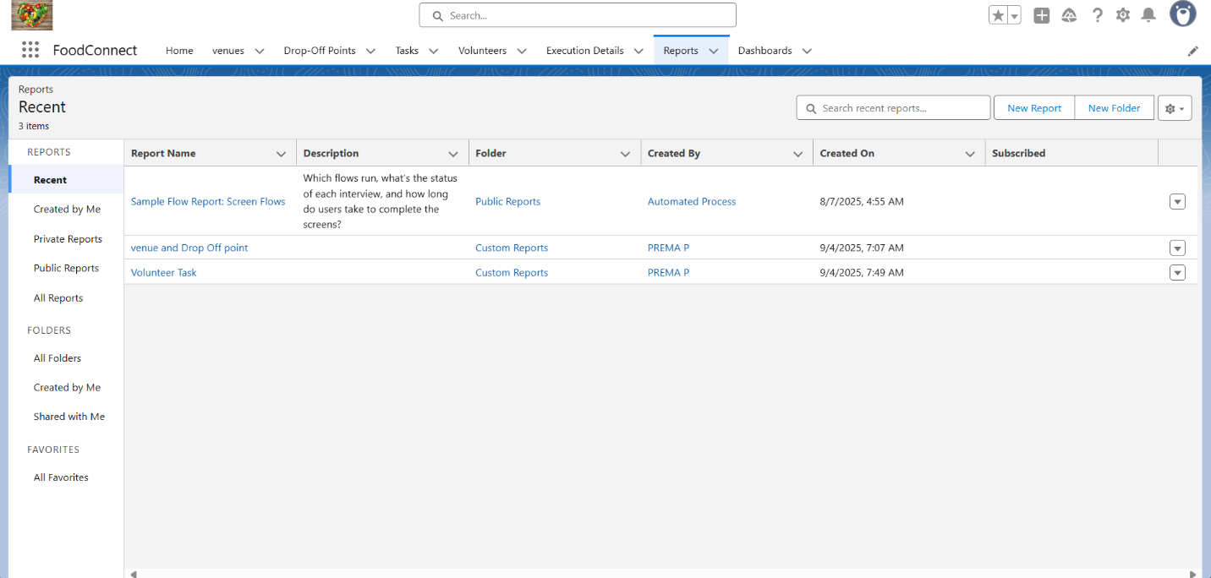

Creation of Report on Volunteers with Execution Details and Tasks:

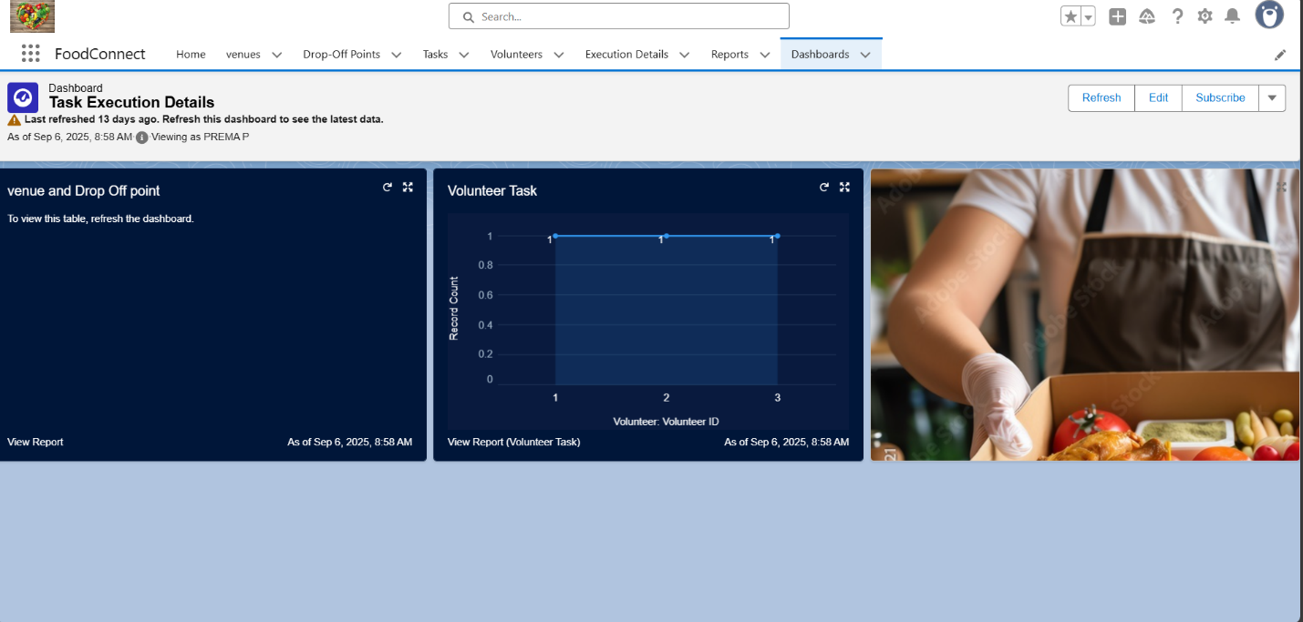

**Dashboard:**

Adding venue and Drop Off point Report to the Dashboard:

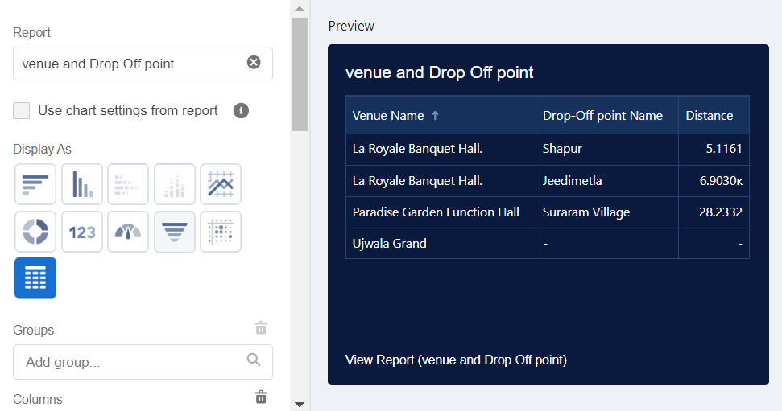

Adding Volunteer Task Report to the Dashboard:

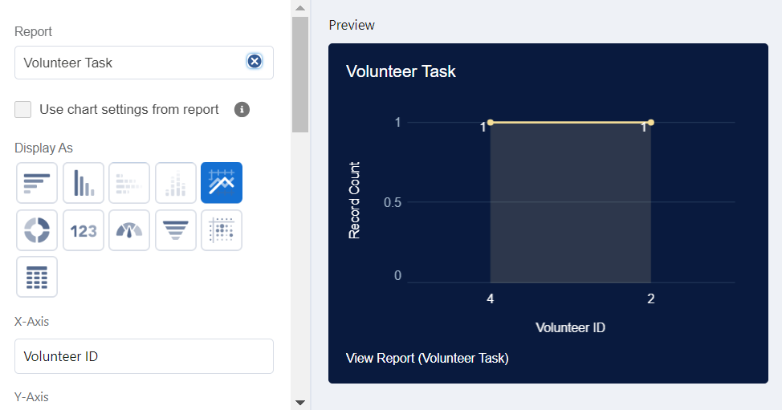

Adding a Picture to the Dashboard (Optional):

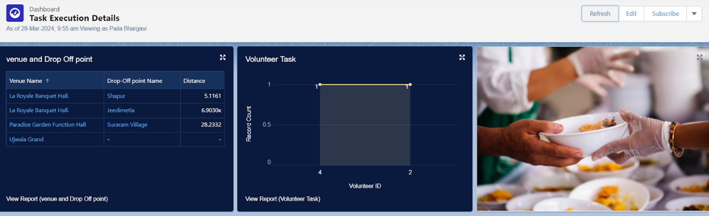

**Sharing rules:**

Creation of sharing rules

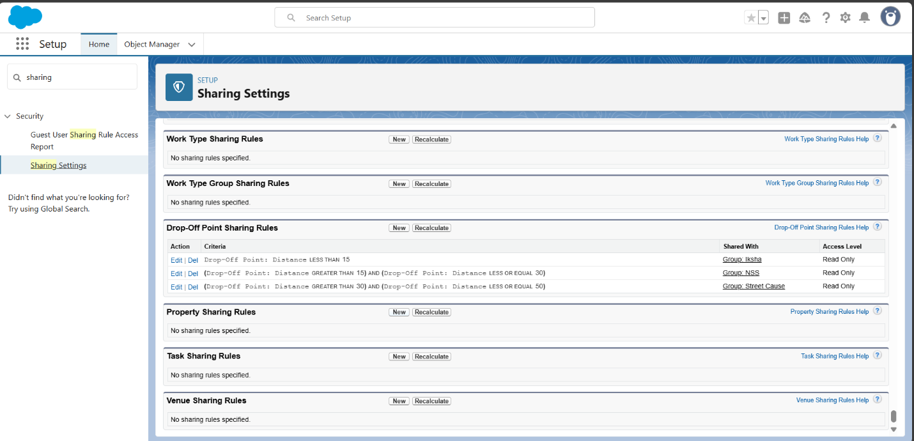

Home page:

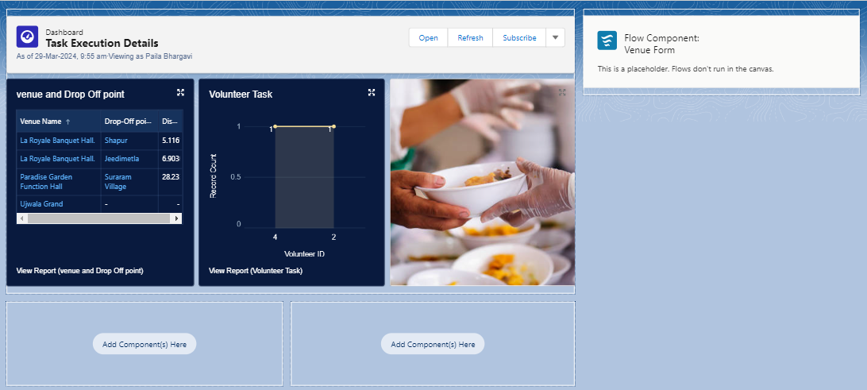

OUTPUT :



**Advantages :**

* **Addresses Immediate Hunger:**

Provides essential nutrition to vulnerable populations, preventing hunger and famine.

* **Improves Health and Well-being:**

Combats malnutrition, improving the physical and mental health of children and adults.

* **Supports Education:**

School feeding programs increase attendance, concentration, and performance, which improves future earning potential.

* **Reduces Food Waste:**

Donations of surplus food can be a sustainable way to reduce food waste, turning a potential environmental problem into a social benefit.

* **Fosters Community & Social Value:**

Encourages community involvement and provides recipients with economic relief by reducing their food expenses.

**Disadvantages :**

* **Food Dependency:**

Can create a dependency on external aid, hindering the development of sustainable, self-sufficient domestic food production in recipient countries.

* **Logistical Challenges:**

Distributing food effectively and efficiently can be difficult due to poor infrastructure, especially in rural areas.

* **Nutritional Imbalance:**

Donated food may lack variety, leading to a less nutritious diet for recipients.

* **Financial Investment:**

Programs require significant public and private funding to operate and can place a strain on resources.

* **Potential for Misuse:**

Food aid can sometimes be diverted or misused, diminishing its effectiveness.

**CONCLUSION:**

A project to supply food to the poor should conclude by emphasizing its impact on alleviating hunger and malnutrition, fostering a sense of community, promoting health, and raising awareness about food wastage and poverty